GeeksForGeeks

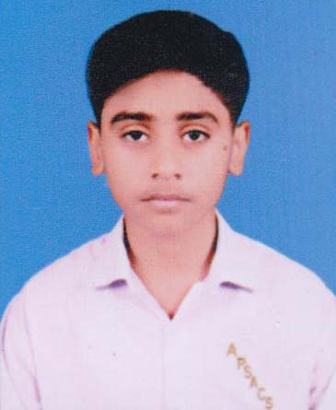

### Image with Defined Size: